**Set of 2 Historical Framed Art**

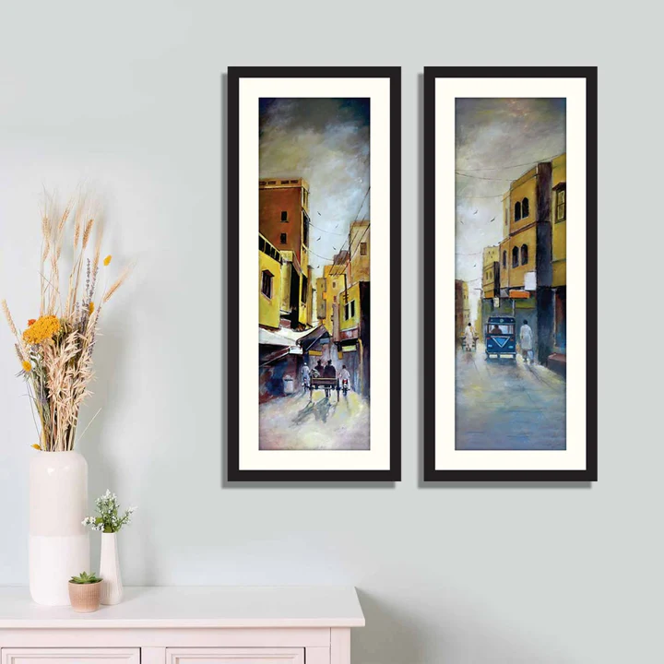The set of 2 historical framed art pieces offers a refined and timeless aesthetic, perfect for showcasing the beauty of iconic landmarks or historical sites. Each artwork captures the essence of history through detailed illustrations or photographs, bringing stories of the past into your space. Encased in elegant frames, these pieces seamlessly complement both traditional and modern interiors. Whether displayed in a living room, study, or office, this set adds a touch of sophistication and cultural depth, making it ideal for history lovers and art enthusiasts alike.